Task No 01:

Which type of sorting do you want to apply? Create a menu using methods having the following options:

1. Bubble Sort Method
2. Selection Sort Method
3. Insertion Sort Method

Solution:

using System;

using System.Collections.Generic;

using System.Linq;

using System.Text;

using System.Threading.Tasks;

namespace dsalab2

{

 class Program

 {

 static void Main(string[] args)

 {

 //int[] arr = {5,8,17,8,9,6,3,1,4,3,0};

 int[] arr = new int[5];

 for (int i = 0; i < 5; i++)

 {

 Console.Write("Enter number: ");

 arr[i] = int.Parse(Console.ReadLine());

 }

 int rep;

 Console.WriteLine("MENU:");

 Console.WriteLine("1.Bubble sort method");

 Console.WriteLine("2.Selcection sort method");

 Console.WriteLine("3.Insertion sort method");

 Console.WriteLine("(hint type 1,2,3):");

 rep = int.Parse(Console.ReadLine());

 switch (rep)

 {

 case 1:

 bubblesort(arr);

 break;

 case 2:

 selectionsort(arr);

 break;

 case 3:

 insertionsort(arr);

 break;

 default:

 Console.WriteLine("invalid choice!");

 break;

 }

 Console.ReadKey();

}

 static void selectionsort(int[] arr)

 {

 int temp, smallest;

 for (int i = 0; i < arr.Length - 1; i++)

 {

 smallest = i;

 for (int j = i + 1; j < arr.Length; j++)

 {

 if (arr[j] < arr[smallest])

 {

 smallest = j;

 }

 }

 temp = arr[smallest];

 arr[smallest] = arr[i];

 arr[i] = temp;

 }

 Console.Write("sorted array : ");

 for (int i = 0; i < arr.Length; i++)

 {

 Console.Write(" " + arr[i]);

 }

 }

 static void insertionsort(int[] arr)

 {

 for (int i = 0; i < arr.Length - 1; i++)

 {

 for (int j = i + 1; j > 0; j--)

 {

 if (arr[j - 1] > arr[j])

 {

 int temp = arr[j - 1];

 arr[j - 1] = arr[j];

 arr[j] = temp;

 }

 }

 }

 Console.Write("sorted array : ");

 for (int i = 0; i < arr.Length; i++)

 {

 Console.Write(" " + arr[i]);

 }

 }

 static void bubblesort(int[] arr)

 {

 int k;

 for (int m = arr.Length; m >= 0; m--)

 {

 for (int i = 0; i < arr.Length - 1; i++)

 {

 k = i + 1;

 if (arr[i] > arr[k])

 {

 int temp;

 temp = arr[i];

 arr[i] = arr[k];

 arr[k] = temp;

 }

 }

}

 Console.Write("sorted array : ");

 for (int i = 0; i < arr.Length; i++)

 {

 Console.Write(" " + arr[i]);

 }

 }

 }

}

Output:

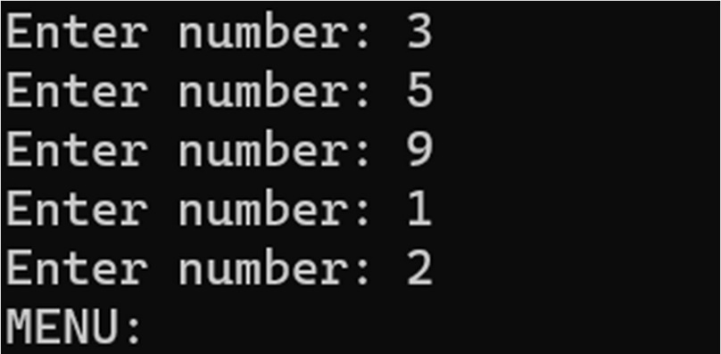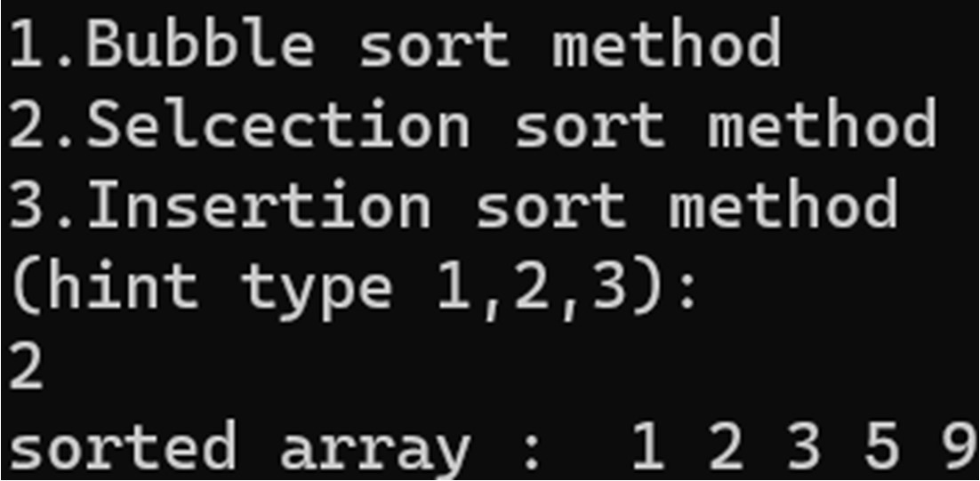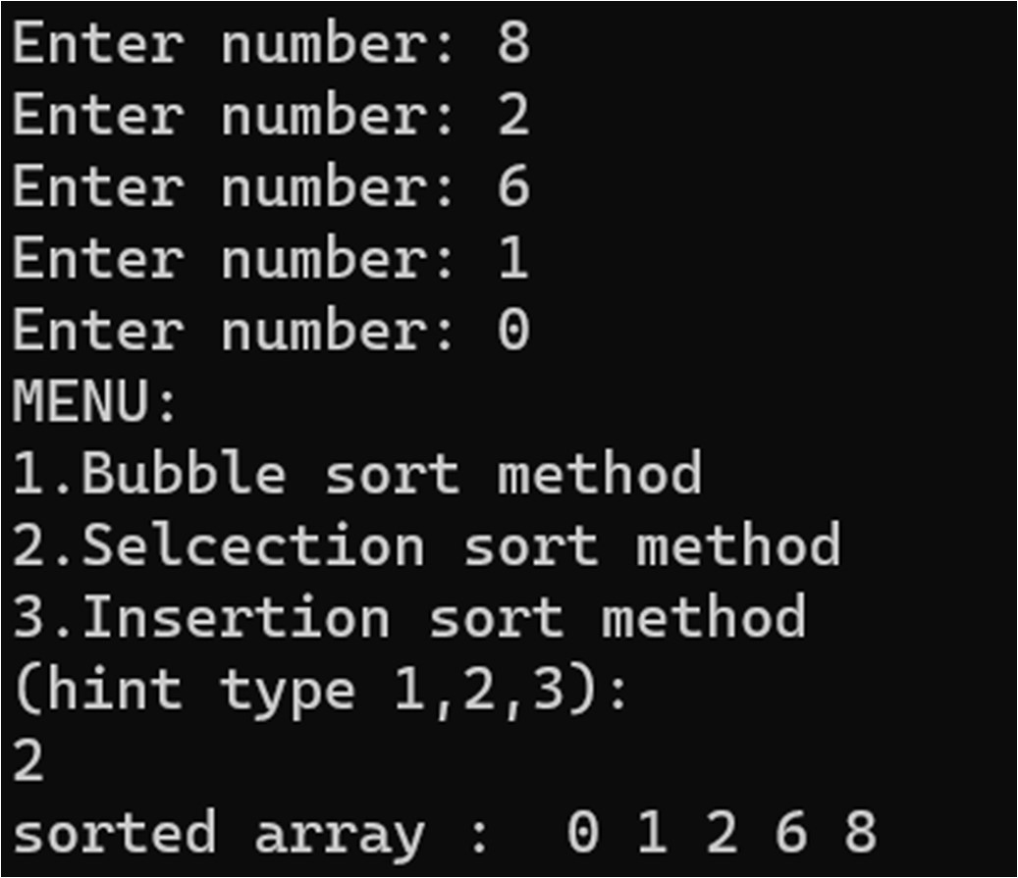

Task No 02:

Implement Selection sort and print string array data in descending order.

Solution:

using System;

using System.Collections.Generic;

using System.Linq;

using System.Text;

using System.Threading.Tasks;

namespace lab2_tsk2

{

 class Program

 {

 static void Main(string[] args)

 {

 //string[] arr = { "sami", "usman" ,"omair", "owais" ,"jawad" ,"husnain"};

 string[] arr = new string[5];

 for (int i = 0; i < 5; i++)

 {

 Console.Write("Enter name: "); arr[i] = Console.ReadLine();

 }

 string temp; int smallest;

 for (int i = 0; i < arr.Length - 1; i++)

 {

 smallest = i;

 for (int j = i + 1; j < arr.Length; j++)

 {

 int res = string.Compare(arr[j], arr[smallest]); if (res == 1)

 {

 smallest = j;

 }

 }

 temp = arr[smallest]; arr[smallest] = arr[i]; arr[i] = temp;

 }

 Console.Write("sorted array : ["); for (int i = 0; i < arr.Length; i++)

 {

 Console.Write(" " + arr[i]);

 }

 Console.Write("]"); Console.ReadKey();

 }

 }

}

Output:

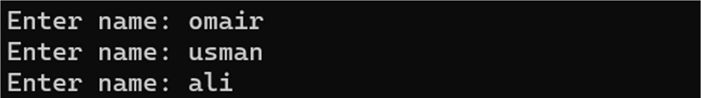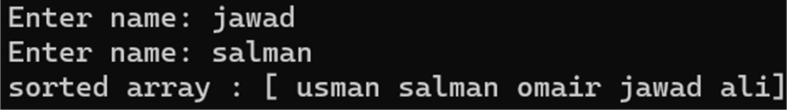

Task No 03:

A Detox chemical Industry has a list of chemicals along with their concentration and Volume. Your task is to list down the name of chemicals in descending order based on their Volume. To fulfil the task, you must select any of the sorting method taught in today’s lab with proper reasoning of usage of that algorithm.

Solution:

using System;

namespace lab2tsk3

{

 class Program

 {

 static void Main(string[] args)

 {

 string[] name = new string[3]; int[] arr = new int[3];

 int[] arr1 = new int[3];

 for (int i = 0; i < arr.Length; i++)

 {

 Console.Write("Enter chemical name: "); name[i] = Console.ReadLine();

Console.Write("enter volume : "); arr[i] = int.Parse(Console.ReadLine()); Console.Write("enter

concentration : "); arr1[i] = int.Parse(Console.ReadLine());

 }

 int temp, con; string name1; int smallest;

 for (int i = 0; i < arr.Length - 1; i++)

 {

 smallest = i;

 for (int j = i + 1; j < arr.Length; j++)

 {

 if (arr[j] > arr[smallest])

 {

 smallest = j;

 }

 }

 temp = arr[smallest]; arr[smallest] = arr[i]; arr[i] = temp;

 name1 = name[smallest]; name[smallest] = name[i]; name[i] = name1;

 con = arr1[smallest]; arr1[smallest] = arr1[i]; arr1[i] = con;

 }

Console.WriteLine("sorted array :"); for (int i = 0; i < arr.Length; i++)

 {

 Console.WriteLine("Chemical : {0} Volume :{1} Concentration:{2}", name[i],

arr[i], arr1[i]);

 }

 Console.ReadKey();

 }

 }

}

Output:

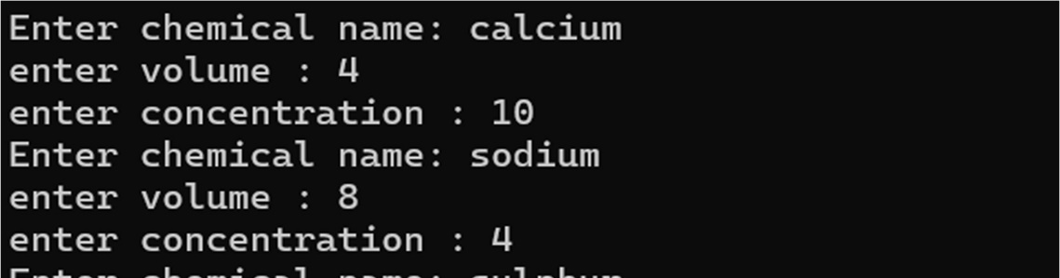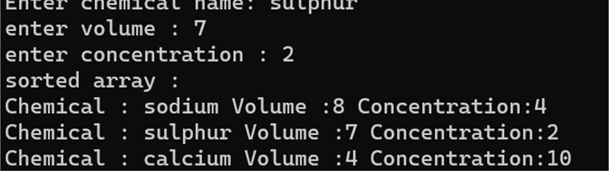

Task No 04:

Write a program which takes input from the user and places the value on correct location in ascending order.

Solution:

using System;

namespace task3

{

 class Program

 {

 static void Main(string[] args)

 {

 int[] arr = new int[5];

 int temp, smallest;

 for (int k = 0; k < arr.Length; k++)

 {

 Console.Write("enter value: ");

arr[k] = int.Parse(Console.ReadLine());

 for (int i = 0; i <= k - 1; i++)

 {

 smallest = i;

 for (int j = i + 1; j <= k; j++)

 {

 if (arr[j] < arr[smallest])

 {

 smallest = j;

 }

 }

 temp = arr[smallest];

 arr[smallest] = arr[i];

 arr[i] = temp;

 }

 }

 Console.Write("sorted array : [");

 for (int i = 0; i < arr.Length; i++)

 {

 Console.Write("{0} ", arr[i]);

 }

 Console.Write("]");

 Console.ReadKey();

 }

 }

}

Output:

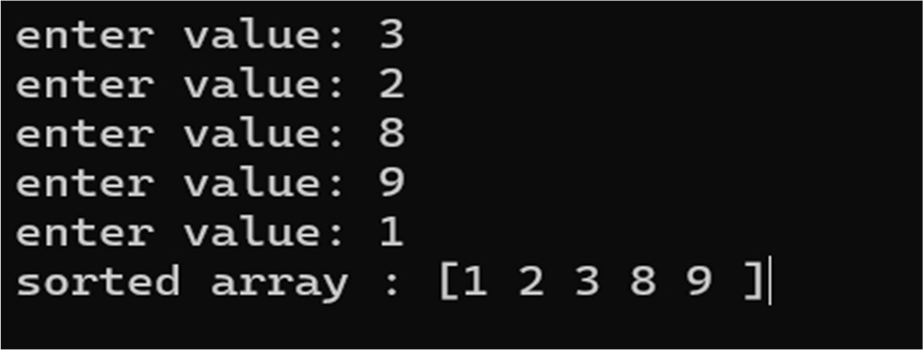

Task No 05:

Write a program which takes N numbers of grocery items from user along with their price. Your main task is to display the items in sorted format. Then allow user to search for any of the item from that list by using name of the item.

Solution:

using System;

using System.Collections.Generic;

using System.Linq;

using System.Runtime.InteropServices;

using System.Text;

using System.Threading.Tasks;

namespace task2

{

 class Program

 {

 static void Main(string[] args)

 {

 Console.Write("Enter number of items: ");

 int n = int.Parse(Console.ReadLine());

 string[] arr = new string[n];

 float[] price = new float[n];

 for (int k = 0; k < n; k++)

 {

 Console.Write("Enter product name: ");

 arr[k] = Console.ReadLine();

 Console.Write("Enter product price: ");

 price[k] = float.Parse(Console.ReadLine());

 for (int i = 0; i <= k; i++)

 {

 int smallest = i;

for (int j = i + 1; j <= k; j++)

 {

 int res = string.Compare(arr[j], arr[smallest]);

if (res < 0)

 {

 smallest = j;

 }

 }

 string temp = arr[smallest];

 arr[smallest] = arr[i];

 arr[i] = temp;

 float p = price[smallest];

 price[smallest] = price[i];

 price[i] = p;

 }

 }

 Console.WriteLine("sorted array : [");

 for (int i = 0; i < arr.Length; i++)

 {

 Console.Write("{0} {1}\n", arr[i], price[i]);

 }

 Console.WriteLine("]\n");

 string rep;

 do

 {

 Boolean f = false;

 Console.WriteLine("Search from the list by name: ");

 string name = Console.ReadLine();

 for (int i = 0; i < n; i++)

 {

 if (arr[i] == name)

 {

 Console.WriteLine("{0} : {1}", arr[i], price[i]);

 f = true;

 }

 }

if (f == false)

 {

 Console.WriteLine("Item does not exist!");

 }

 Console.WriteLine("\nDo you want to search again?(type yes): ");

 rep = Console.ReadLine();

 } while (rep.Equals("yes"));

 }

 }

}

Output:

